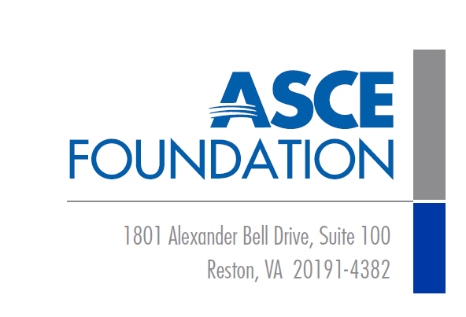

Sustainable Infrastructure Initiatives

Support ASCE’s Sustainable Infrastructure Initiatives, including the International Conference on Sustainable Infrastructure 2019 (ICSI 2019) with your corporate gift to the ASCE Foundation and be formally recognized as an ASCE Foundation supporter.

https://www.icsiconference.org/sponsors

A. Yes! I would like to support the ASCE Foundation’s Sustainable Infrastructure Initiatives Fund as an ICSI 2019 Sponsor.
Sponsorship: Sponsorship Amount:
Enclosed is my check (Payable to the “ASCE Foundation,” memo “SII Fund”)
- Please send an invoice for full payment to the individual listed in B. D. below.
- I would like to give via credit card:
Visa MasterCard Discover American Express
Cardholder’s Name:
Credit Card Number: Expiration Date:
Billing Address:
Zip Code:
B. Contact Information
Organization:
Contact Name: Title:
Mailing Address:
Email: Phone:
C. Public Recognition
Give public recognition for this gift to:

D. Name and Signature of the individual with the authority to make this financial commitment on behalf of the organization identified in B. above.
Name: Title:
Phone: Email:
Signature:

